Managers’ Toolkit Briefing - How good is your listening?

Purpose: To highlight the importance of listening
Time: 5-10 minutes

This session is designed to highlight a specific skill that will enable us to support someone who may be in distress on the railway. This briefing is about listening. People in crisis often feel they are not being listened to – we have a great opportunity to listen when we make an intervention.

In today’s quick session we’re going to go through Samaritans SHUSH listening tips.

SHUSH tips – top tips for becoming a better listener – they are simple and straightforward.

Show you care  Q. How could you show someone, a complete stranger in crisis perhaps, that you care?  A. By listening to them, our body language, telling them you care about their wellbeing.  Have patience  Q. Why should we have patience?  A. Because often people in distress struggle to talk about what they are going through. It may take more than one attempt for them to begin talking. | 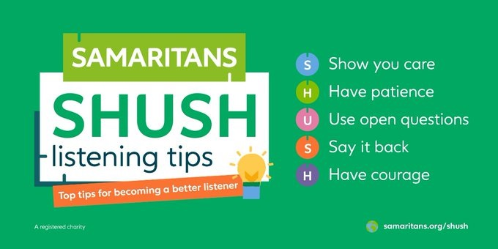

Use open questions
Q. What is an Open Question?
A. A question they cannot respond with a ‘yes’ or ‘no’.

Say it back
Literally using their words back to them – if they say ‘I’m cold’, we may simply say it back – ‘you’re cold?’. The other person will know they have been listened to when we repeat back what we have heard using their own words.

Have Courage
In this instance it’s not physical courage we are referring to – we are not encouraging physical interventions and your safety is of paramount importance – but the courage to approach someone you believe may need help.

The SHUSH tips are universal – you could use them in or out of work to become a better listener. In the next session we discuss the start of an intervention.

For further information and more detail please access the Learning Tool https://railsuicideprevention.co.uk/ and / or book yourself onto the Managing Suicidal Contacts and / or Trauma courses by emailing railcompanies@samaritans.co.uk.

